PART I: MULTIPLE CHOICE 008QUESTIONS (15 points)
1. Which element is INCORRECTLY matched with its symbol?
a) Cu / copper b) Pb / lead
c) K / potassium d) B / bismuth
2. The density of Au is 19.3 g/mL. What would be the value of a 100 cm3 ingot of gold if gold is worth $35 per ounce. (Note: There are 16 ounces in a pound; 1 pound = 0.4536 kg)
a) $ 123 c) $ 3,500
b) $ 2,383 d) $ 440
3. Nichrome is an alloy (mixture) commonly used to make heating elements. It is composed of 60% nickel, 24% iron and 16% chronium. If you have 2.15 g of nichrome wire, how much of each element do you have?
a) 1.6g Ni, 0.31g Fe, 0.24g Cr b) 1.6g Ni, 0.41g Fe, 0.14g Cr c) 1.3g Ni, 0.52g Fe, 0.34g Cr d) 1.2g Ni, 0.61g Fe, 0.14g Cr
4. In which item below is the result expressed INCORRECTLY in terms of number of significant figures?
a) 3.14 x 2.584 = 8.11
b) 0.003/0.0015 = 2
c) 1.314 + 189.71 = 191.0
d) all results are corrected.
5. Which of the following is NOT an SI unit of that measured quantity?
a) Length is expressed in meters
b) Energy is expressed in pokemon
c) Time is expressed in seconds
d) Mass is expressed in kilograms
6. Which of the following numbers has 4 significant figures?
a) 0.04309 b) 0.0430
c) 0.043090 d) 0.43980
7. Atoms are composed of:
a) protons, neutrons, electrons b) protons, neutrinos, elections c) positrons, neutrons, electrons d) positrons, neutrons, negatrons
8. Choose the correct answer:
a) cations have a positive charge, anions have a negative charge
b) anions have a positive charge, cations have a negative charge
c) the opposite of a cat ion is a dog ion d) uh, what?
9. Which two subatomic particles have approximately the same mass?
a) electrons and nuclei
b) neutrons and electrons
c) protons and electrons d) protons and neutrons
10. Isotopes are atoms of the same element that:
a) have different numbers of electrons.
b) have different numbers of protons.
c) have different numbers of neutrons.
d). have different atomic numbers
11. The mass spectrum shown above for an element shows two mass peaks. Predict the atomic mass (g/mole) for this element.
a) 25.8 b) 26.0
c) 25.5 d) 25.0
12. How many neutrons are in the nucleus of this element: 226Ra
a) 138 c) 226
b) 88 d) 108

13. Select the element with the electron configuration: [Kr] 5s2 4d2.
a) Hf b) Y
c) Zr d) Ti
14. Which combination of protons, neutrons,
and electrons is correct for the 63Cu isotope of Copper?
a) 29 protons, 34 neutrons, and 29 electrons b) 29 protons, 29 neutrons, and 63 electrons c) 63 protons, 29 neutrons, and 63 electrons d) 34 protons, 29 neutrons, and 34 electrons

15. Which of the following elements has the lowest first ionization energy?
a) Be c) Ca
b) Mg d) S
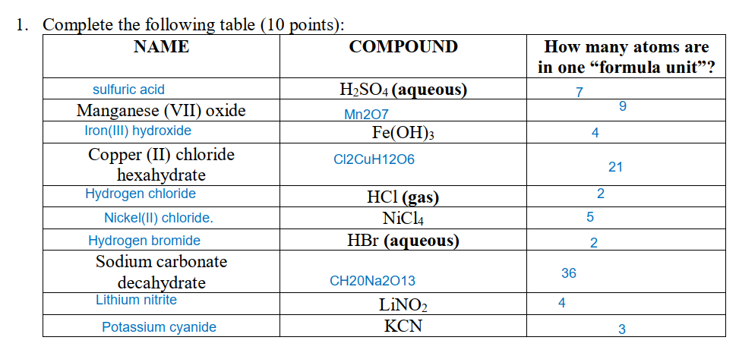

- Draw a sketch of an atom. Label the nucleus, protons, neutrons and electrons and answer
following questions (8 pts):
a. Comparing the mass of a neutron to the mass of a proton and a electron, what can we
say about this?
b. How large is the nucleus compared to the size of an atom?
c. Atoms of the same element that have different masses are called what?
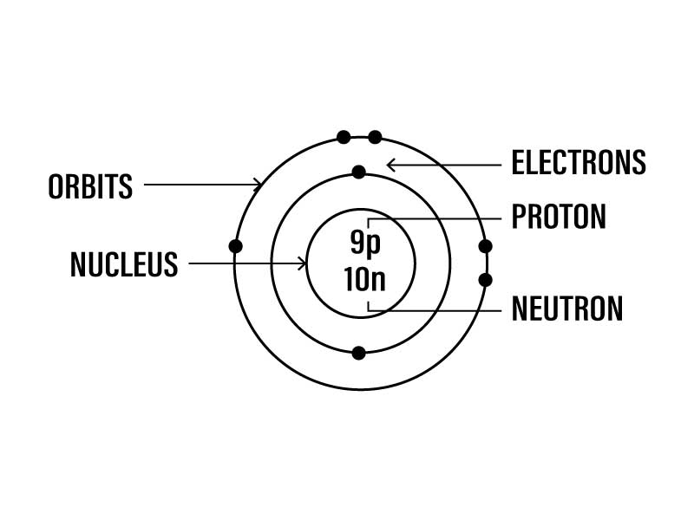
a. Comparing the mass of a neutron to the mass of a proton and a electron, the neutron is more massive than the proton and the electron. Specifically, the mass of a neutron is about 1.008665 amu (atomic mass units), while the mass of a proton is about 1.007276 amu and the mass of an electron is about 0.0005485799 amu.

b. The nucleus is very small compared to the size of an atom. In fact, the nucleus is typically only about 100,000 times smaller than the size of the atom. However, despite its small size, the nucleus contains nearly all of the mass of the atom.

c. Atoms of the same element that have different masses are called isotopes. Isotopes of an element have the same number of protons in their nucleus, but they may have different numbers of neutrons. This difference in the number of neutrons results in isotopes having different atomic masses.

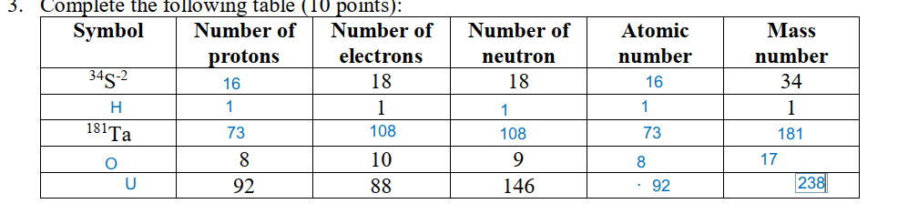
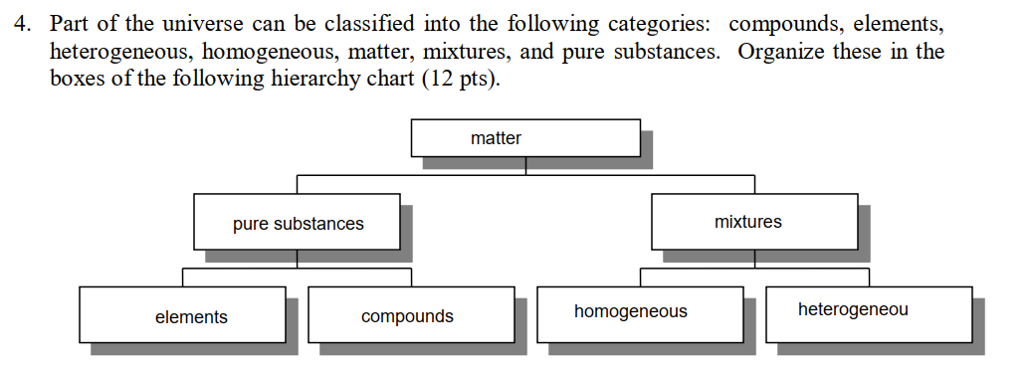

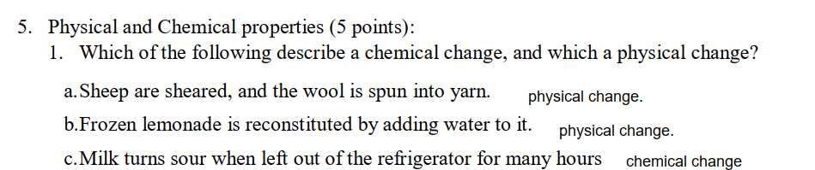
2 Underline the chemical property/properties of chlorine.
At 25°C, chlorine is a green-yellow gas with a density of 3 × 10–3 g/cm3. Chlorine has a
melting point of –101°C and a boiling point of –35°C, and the energy required to melt and boil chlorine is 6.4 and 20.4 kJ/mol, respectively. Chlorine burns in hydrogen to form hydrogen chloride.

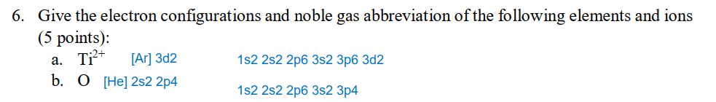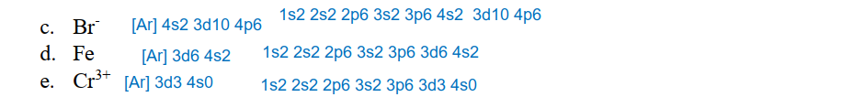
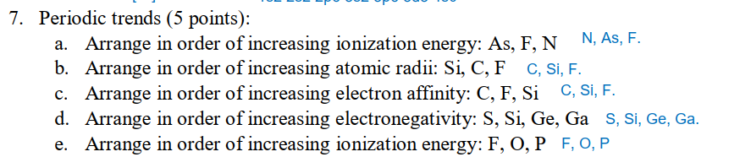
- The formula of a salt is XCl2. The X-ion in this salt has 28 electrons. The metal X is Cu.- FALSE, the mental X is Zn
- Silver has two naturally occurring isotopes 107Ag (106.9051 amu) and 109Ag (108.9048 amu). The average atomic mass of silver is 107.8682 amu. The fraction abundance of 107Ag is 0.5184. TRUE
- Name of compound NH4Cl (g) is ammonia hydrochloric. FALSE -> ammoni chlorua
- Almost all of the mass of the atom is concentrated in the nucleus. TRUE
- The protons and neutrons in the nucleus are very tightly packed. TRUE
- An element with the outermost electron configuration ns2 np3 would be in group IIIA FALSE -> In group VA
- The electron configuration of selenium (Se) is [Ar] 4s2 3d10 4p4 . TRUE
- V has 3 unpaired electrons. TRUE
- Ca has 2 valence electrons. TRUE
- Milk tea with bubbles is the example of homogenous mixture. FALSE -> heterogenous mixture
- Maleic acid, which is used to manufacture artificial resins, has the empirical formula CHO. Its molar mass is 116.1 g/mol. Its molecular formula is C4H4O4. TRUE
- Ca2+ < Sr2+ < Rb+ < Br- < Se2- is the trend of increasing radius of these following ions.
- The cation’s ground-state electron configuration of Co(C2H2O3).4H2O is [Ar] 3d7 4s2
- A positive charge particle found in the nucleus is called electron. FALSE -> proton
- The reaction of Mg metal with oxygen to form magnesium oxide is an example of a chemical change. FALSE -> chemical property
- An atom is the smallest particle of an element that maintains the chemical identity of that element. TRUE
- Molecules that consist of more than one atom are called polyatomic molecules. FALSE -> consist of more than three atoms
- Elements with atomic numbers of 9, 17, 35, and 53 are members of the halogen family, meaning "salt formers." TRUE
- In the most fundamental sense, the properties of the elements are periodic functions of their atomic weight. FALSE -> atomic number
- The elements at the far right of the periodic table, except the noble gases, have the greatest tendency to form anions. TRUE
- Metals have lower ionization energies than nonmetals. TRUE

